Module 12 – Location Graph

Exploratory Data Analysis

*In this section, you should perform some data analysis on the data provided to you. Please format your findings in a visually pleasing way and please be sure to include these cuts:*

* *Make a visual graph of your data on a map (coordinates should be within US borders)*
  + <https://mymaps.google.com/>
  + Find a map with latitude/longitude and place them approximately
  + Any alternative that gives the same effect
* Use your available data to determine a good starting coordinate for the DC
  + Should you use the average of the ranges of lat longs of the stores?
  + Should you use the coordinates of the store furthest away from the current DC?
  + Can you think of something better to use?
  + Whatever you use, please record the optimal function with your starting coordinate to compare to your optimized model

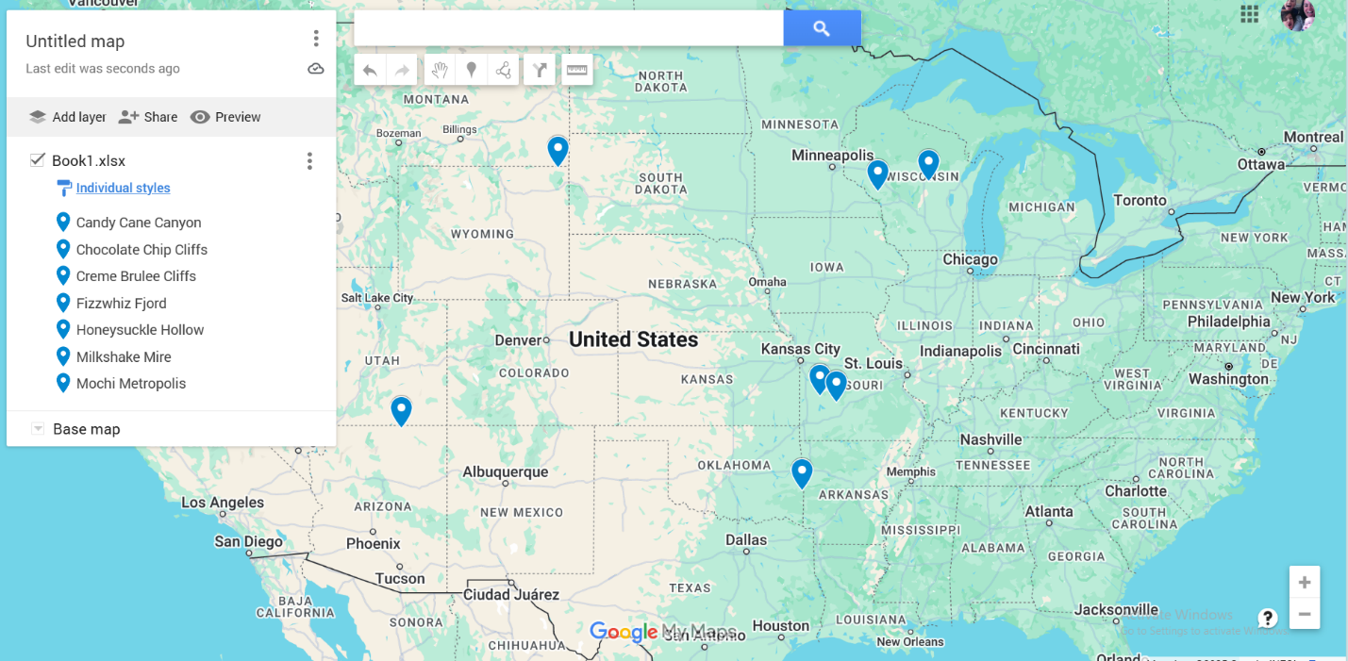

Model Formulation

*Try to write the formulation of the model into here prior to implementing it in your Excel model. Be explicit with the definition of the decision variables, objective function, and constraints. Hint: Linking constraints aren’t needed since we are using Nonlinear GRG but refer to the associated PowerPoint in your data if you need help.*

Model Optimized for Distance Reduction from DC to Store

*Implement your formulation into Excel and be sure to make it neat. This section should include:*

* *A screenshot of your optimized final model (formatted nicely, of course)*
* *A text explanation of what your model is recommending*
* *Update your graph from the EDA section by adding in your new DC and add indicators of which Stores are serviced by which DC*

Model with Stipulation

*Please copy the tab of your original model before continuing with the next part to avoid messing up your original solution.*

*You should notice that while distance is minimized between each store and each DC, there is a discrepancy between how much demand is serviced between each DC (i.e. one DC may service a lot more demand than others). Please:*

1. *Choose one:*
   1. *Implement a change that picks a location for the new DC to distance AND load. You can do this by multiplying distance by demand if a store is serviced by a particular DC.*

*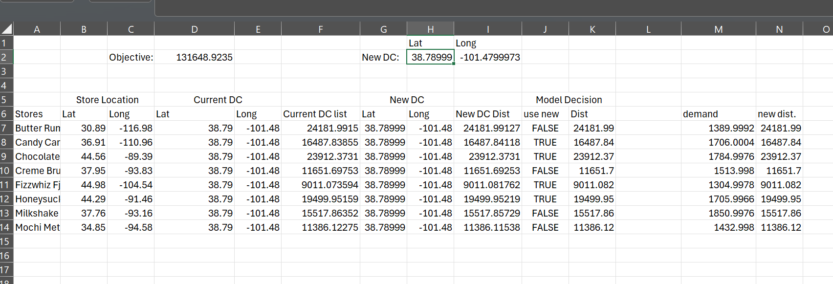*

* 1. *Instead of just summing the distance, also add the difference between demand serviced between each DC (i.e. if the old DC serves stores with 8000 total demand and the new DC does 3000 then the difference would be 5000). Be sure to not remove the sum of distance too, it should be both. You may want to add weights and such but not necessary*

1. *Provide a text explanation on what your model is recommending now with this change.*

The new DC site is now picked to serve not only the closest stores but also those with greater demand after we included demand into our model by multiplying each store's distance by its demand. This change guarantees that the choice gives more weight to the most essential (higher volume) stores. The model thereby strikes a compromise between distance efficiency and service effect, which results in a more strategically and reasonably priced location for the new distribution center.

1. *Explain the changes to your Solver/Model.*

In the updated model, I made changes in both the Excel sheet and Solver to include demand when deciding where to place the new distribution center. I added a new column that multiplies each store’s distance by how much demand it has. This helps the model focus more on stores that need more deliveries. Then, I changed the total distance formula so it adds up all these weighted distances instead of just the regular distances. In Solver, I set this new total as the objective to minimize and kept the new DC’s latitude and longitude as the variables that can change. I still used the GRG Nonlinear solving method because of the square root in the distance formula. This change helps find a location that works better for the busiest stores, not just the closest ones.